Summaries about the Cobot AI Algorithm Controlling Project:
At first, I decide to just install the indicator on the 6DOF Cobot to test on a reference point or line to measure the precision. The AI agent (Gemini Pro) suggest to use the laser to point a laser point on a reference paper install nearby. With this option, we require a camera can detect the point on the paper. This can be a good approach to testing a precision of the AI algorithm controlling. So, in this robot controlling algorithm project, we can do both.
Hardware requirements:
Hardware | Status | Picture | Note
The Cobot – IGUS Rebel 6-DOF | Available in Innovation Hub and Maker Space | 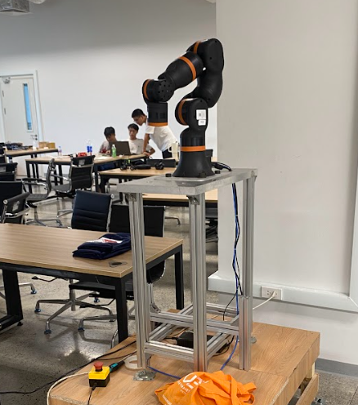
Dial Indicator | Available in Innovation Hub and Maker Space | 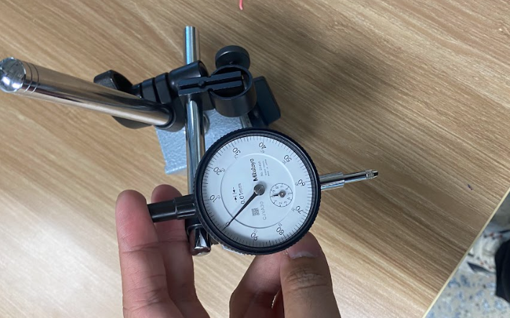
Indicator Setup | Required to design and do 3d printing. |  | PETG filament required.  Estimated: ~1 kg/ filament  (don’t have any stock yet)
Laser Pointer | Required to buy a new one | 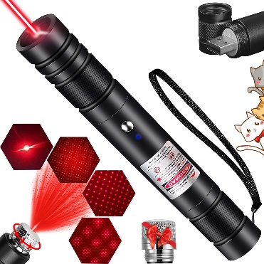 | Cheap rice is enough
Laser Pointer Setting:  + Camera to detect the point on the paper  + A ruler grid paper as a target for Laser point (Laser Dot) | Required to buy a new camera  Required to design and printing the reference paper |  | Camera price and type need to be researched carefully.

Task to do:
- Build a software to simulation and control the Cobot normally. It will be used to be the simulation environment and working at a Digital Twin for future controlling.
- Define the AI – based controlling definition that we want to do with our project. For this definition, I have put on the AI and get the response like this [2].

My final words:
- In this case, I need to discuss with you because I don’t know which idea that we should choose to control the robot for now. Next week, I think we should meet one more time in next week to get the final idea for this research after weekends. Of course, I will do properly research in this weekend to finalize the idea into a professional research. This AI suggestion below can be the reference but I don’t think it’s good to follow. Although, these parameter could be considered to choose at our final analysis parameters.
Analysis Parameter for comparision
Parameter | What it tells you
Pose Repeatability | Does the algorithm output the exact same joint angles every time for the same target?
Absolute Accuracy | Can the algorithm hit a brand new coordinate it has never seen before?
Inference Latency | Is the AI faster at calculating complex poses than traditional calculus?
Joint Smoothness | Is the AI causing micro-stutters that could damage the ReBeL's polymer gears?
Failure Rate | How safe and reliable is the AI for industrial use?

[1] Response of AI for planning a project use Indicator and Laser point.

1. Hardware & Software Requirements

Hardware
- The Robot: igus ReBeL 6-DOF cobot with power supply and Ethernet cable.
- Safety: Physical Emergency Stop (E-Stop) button connected and within reach.
- Compute: A PC running Ubuntu 22.04 or 24.04 with a dedicated GPU (e.g., NVIDIA RTX series) for AI training and fast inference.
- Indicator Setup: Dial indicator (0.01mm precision), 3D-printed breakaway tool-flange mount, and a heavy, flat metal calibration block.
- Laser Setup: Standard laser pointer (pen style or diode module), 3D-printed mount, and A3/A4 millimeter graph paper taped to a rigid, flat board.

Software
- Core: ROS 2 (Humble or Jazzy) and MoveIt 2.
- Simulation: Gazebo Harmonic and RViz2.
- AI Stack: Python 3, PyTorch (or TensorFlow), and NumPy.

2. The 2-Month Master Plan (8 Weeks)

Phase 1: Baseline Setup & Traditional Testing (Weeks 1 - 2)
- Week 1: Digital Twin & Hardware Prep
  - 3D print both the indicator breakaway mount and the laser pointer mount.
  - Connect the ReBeL to the PC via the ros2-igus-rebel driver.
  - Verify the robot matches its digital twin in RViz2.
- Week 2: The Baseline Math Experiments
  - Run the Dial Indicator Test (Repeatability) using traditional Inverse Kinematics (MoveIt 2 TRAC-IK). Loop the robot to the metal block 50 times and record the dial readings.
  - Setup the graph paper and run the Laser Pointer Test (Accuracy). Feed 20 random coordinates to MoveIt 2, mark where the laser lands, and log the data.

Phase 2: AI Development & Training (Weeks 3 - 4)
- Week 3: Data Generation
  - Write a script in ROS 2 simulation to generate 100,000 valid pairs of Cartesian coordinates $(x, y, z)$ and their corresponding 6 joint angles.
  - Design your Neural Network (Neural IK) in PyTorch.
- Week 4: AI Training
  - Train the Neural Network using the generated dataset.
  - Validate the model offline (feed it coordinates on your PC and check if the predicted joint angles make mathematical sense before connecting the physical robot).

Phase 3: AI Integration & Testing (Weeks 5 - 6)
- Week 5: The Software Bridge
  - Write a Python node in ROS 2 that takes the output of your AI model (the predicted joint angles) and sends them to the ReBeL's joint trajectory controller.
- Week 6: The AI Dial Indicator Test
  - Mount the dial indicator. Keep speed at 10% and hand on the E-Stop.
  - Ask the AI to calculate the joint angles for the measurement point 50 times.
  - Record the indicator readings to see if the AI's predictions fluctuate (jitter) compared to the math baseline.

Phase 4: Final Testing & Analysis (Weeks 7 - 8)
- Week 7: The AI Laser Pointer Test
  - Swap to the laser pointer mount.
  - Feed the AI the same 20 random coordinates used in Week 2.
  - Execute the movements and measure the distance between the target and the actual laser dot.
- Week 8: Data Crunching & Reporting
  - Compile all data into tables and graphs.
  - Analyze where the AI succeeded and where traditional math performed better.

3. Parameters to Collect & Analyze
To write a strong technical report or paper at the end of this project, you need to track these specific parameters during your testing:
Parameter | How to calculate it | What it tells you
Pose Repeatability | Standard deviation of the dial indicator readings across 50 attempts. | Does the algorithm output the exact same joint angles every time for the same target?
Absolute Accuracy | $d = \sqrt{(y_t-y_a)^2 + (z_t-z_a)^2}$ (Distance between target and actual laser dot). | Can the algorithm hit a brand new coordinate it has never seen before?
Inference Latency | Time in ms from inputting the coordinate to outputting the joint commands. | Is the AI faster at calculating complex poses than traditional calculus?
Joint Smoothness | Derivative of joint acceleration recorded via ROS 2 topics (rad/s^3). | Is the AI causing micro-stutters that could damage the ReBeL's polymer gears?
Failure Rate | Percentage of times the algorithm outputs an impossible or self-colliding pose. | How safe and reliable is the AI for industrial use?

ISO 9409-1 pattern**
[2] Definition of AI Based 6dof Cobot Controlling?
When we talk about "AI-based 6-DOF cobot controlling," we are talking about replacing or assisting traditional mathematical controllers (like PID controllers, calculus, and geometry) with Machine Learning models.
In the robotics industry right now, AI-based control is divided into four main categories. If you are doing a project to compare algorithms, you will likely choose one from Category 1 or Category 2.
Here are the specific AI algorithms used to control a 6-DOF cobot:

1. Reinforcement Learning (RL) Control
The "Trial and Error" Approach
This is the most popular AI method for direct, low-level robot control. You put the digital twin of your ReBeL cobot in a simulation (like Gazebo or Isaac Sim) and let it try to reach a target point millions of times. It gets a "reward" when it gets close and a "penalty" if it crashes.
- The Algorithms:
  - PPO (Proximal Policy Optimization): The absolute industry standard right now. It is highly stable and great for continuous robot movements.
  - SAC (Soft Actor-Critic): Very good at exploring its environment and learning smooth trajectories.
  - DDPG (Deep Deterministic Policy Gradient): An older but very effective algorithm specifically designed for continuous joint control.
- How it works for your project: You feed the AI the target $(x, y, z)$ coordinate and the current joint angles. The AI directly outputs the joint velocities to move the arm to the target.

2. Neural Inverse Kinematics (Neural IK)
The "Math Approximation" Approach
Traditional Inverse Kinematics (IK) uses complex matrices and trigonometry to figure out how to bend the 6 joints to reach a coordinate. Sometimes, this math is slow or gets stuck in a "singularity."
- The Algorithms:
  - Deep Neural Networks (MLP - Multi-Layer Perceptrons): You train a standard, deep neural network on hundreds of thousands of successful movements.
- How it works for your project: Instead of doing math, the AI just memorizes the relationships. You input $(x,y,z)$, and the AI instantly predicts the 6 joint angles ($\theta_1, \theta_2, \theta_3, \theta_4, \theta_5, \theta_6$) in milliseconds.

3. Imitation Learning / Behavioral Cloning
The "Monkey See, Monkey Do" Approach
Instead of letting the robot learn by trial and error, a human uses a joystick or VR controller to move the physical robot to do a task (like picking up a block) 50 times. The AI watches the cameras and the joint data and learns to copy the human.
- The Algorithms:
  - Diffusion Policies: The hottest algorithm in robotics right now (used by Toyota and MIT). It creates incredibly smooth, human-like, continuous movements.
  - ACT (Action Chunking with Transformers): Uses the same technology behind ChatGPT to predict the next physical movement of the robot.

4. Vision-Language-Action (VLA) & Code-as-Policy
The "High-Level Brain" Approach
This doesn't control the individual motors directly. Instead, it acts as the "manager."
- The Algorithms:
  - LLMs (Large Language Models): Models like Gemini 1.5 Pro or GPT-4o.
  - VLA Models: RT-2 (Robotics Transformer 2) or OpenVLA.
- How it works: You type, "Move the laser pointer to the top right corner of the paper." The AI understands the text, looks at a camera feed, and writes a Python script that commands ROS 2 to move the robot.

Which one should you use for your project?
Since your project is about testing precision (Laser Pointer) and repeatability (Dial Indicator) against traditional baseline math, you should choose:
Reinforcement Learning (PPO algorithm) or Neural IK (MLP algorithm).
These are the best for precision point-to-point targeting. Imitation Learning is better for messy tasks (like folding laundry), and LLMs are better for high-level reasoning, not sub-millimeter precision.
If you want to start with the easiest one to program, Neural IK using PyTorch is a fantastic and highly scientific starting point. Are you familiar with PyTorch, or would you like to see how to structure the input/output layers for a 6-DOF robot?

